Aya Mohamed | electrical circuts | October 3, 2022

Difference between capacitors
  - reprt 1

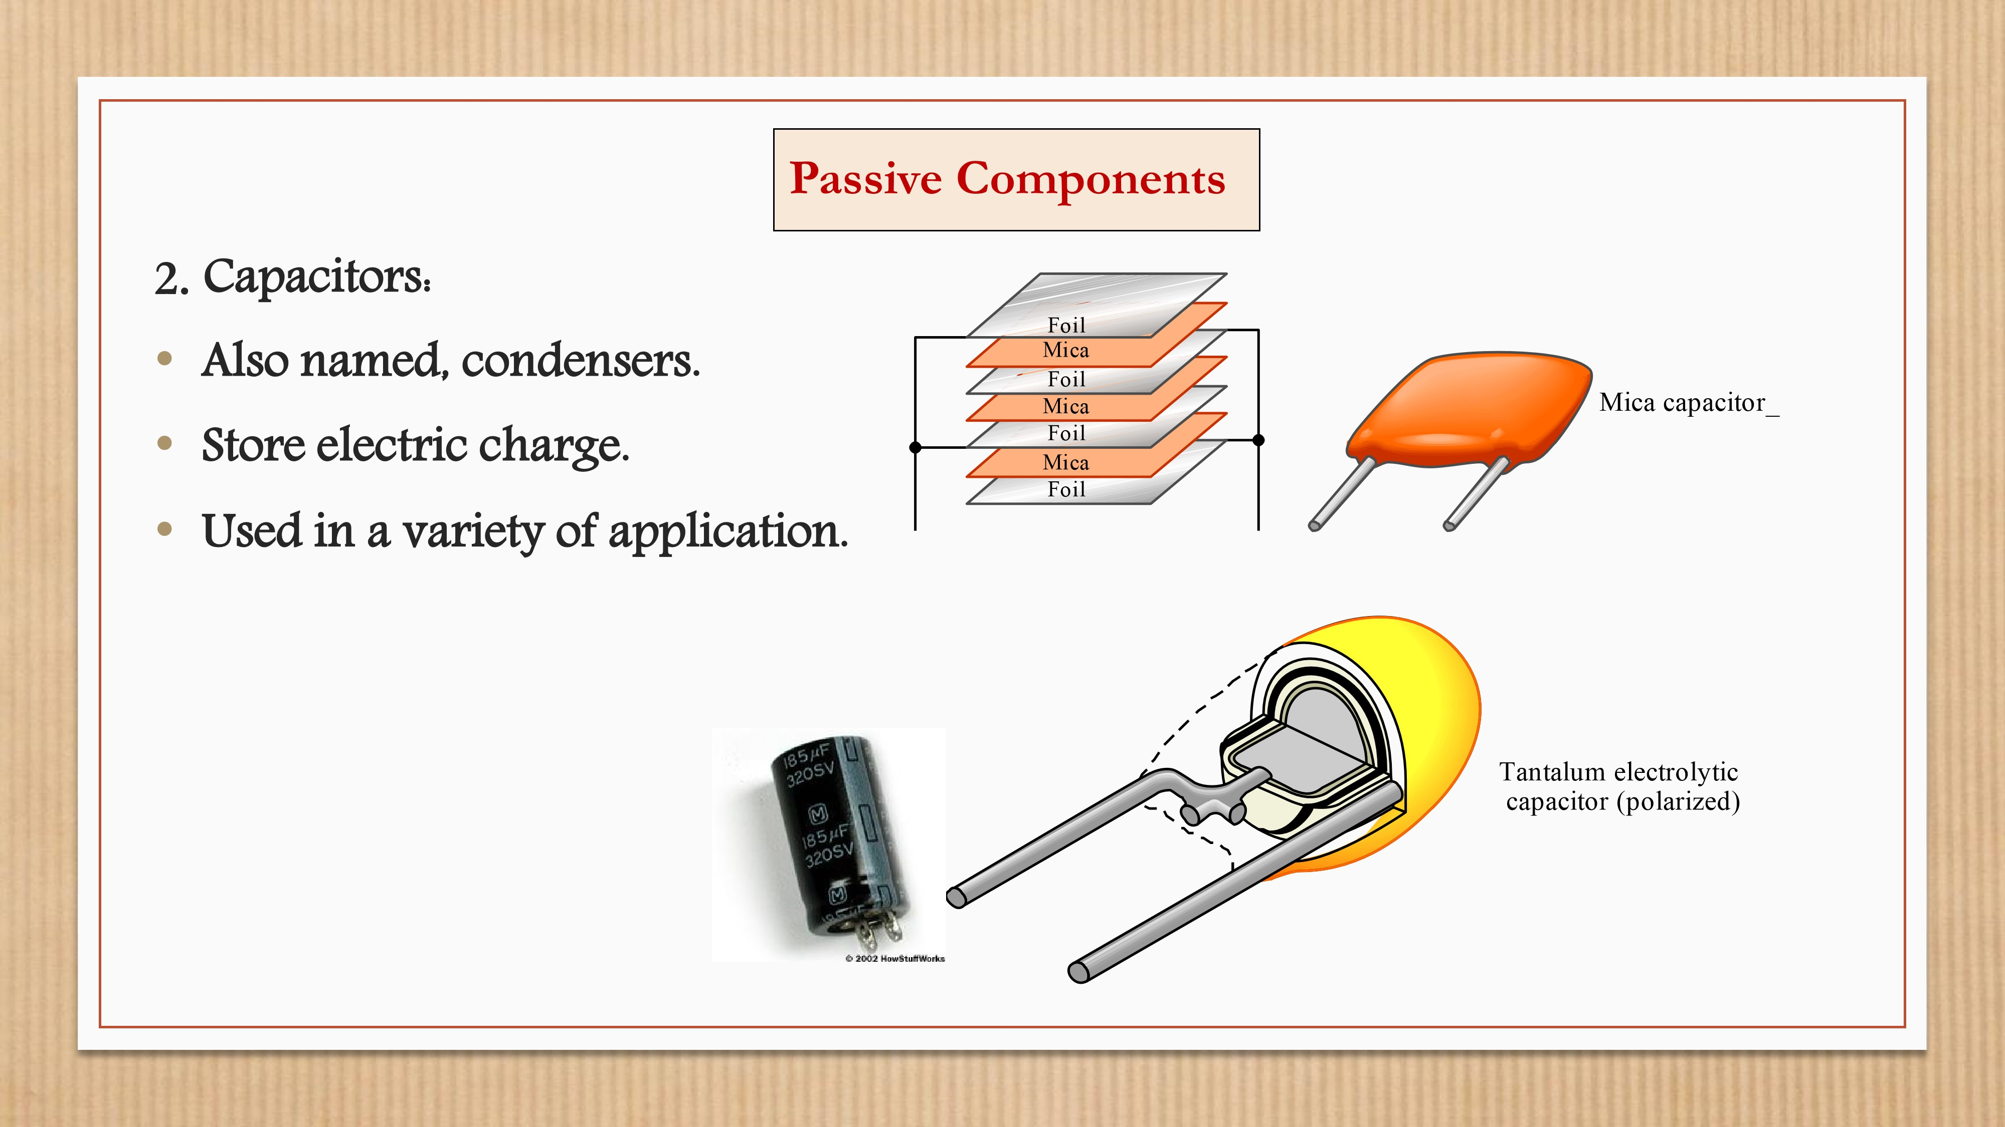
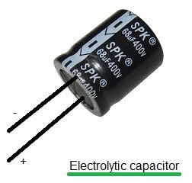
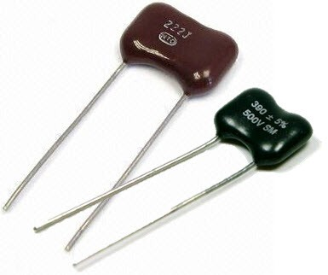
First introduction:
we know that capacitor is used to store electrical energy and has alot of types and used in variety applicatins
IN GENERAL, non polar capacitor is one that has no implicit polarity and can be used in either direction in a circuits But, polar capacitor has an inherent polarity ,meaning it may only be used in one direction . The main difference is what they're made of. Incidentally, that also determines how big they have to be for a given capacitance, and how much they cost.
a)-Electrolytic capacitor
Polar capacitors are also known as electrolytic capacitors, because they use an electrolyte as the dielectric. It allows for extremely high capacitance with some small leakage current in a small package. A ceramic capacitor with equivalent capacitance would have to be very, very large.
Electrolytic capacitors are useful in places where the voltage will never switch polarity on them under proper use conditions. Their high capacitance means they can be used more effectively for power supply filtering, reducing ripple in a rectifier, and softening on/off switching.
But for component decoupling, they aren't so good because without a very good bias, they'll end up with a voltage applied backward, and under backward voltage they break down, lose their capacitance and leak like crazy.
Non polar (mica):
There are lots of different kinds of non-polar capacitors. The two most common ones I've seen are ceramic and mica. Ceramic is cheap, mica is more expensive, but I believe mica capacitors can take a higher voltage. Altogether, they offer lower leakage current than electrolytics but also lower capacitance per size. The main advantage is that they maintain their capacitance with bias in both directions.
APPLICATION OF MICA CAPACITOR:
Applications for mica capacitors
Their main use is in power RF circuits where stability is of utmost importance. Silver mica capacitors are used in high frequency tuned circuits, such as filters and oscillators. They are sometimes used in pulsed applications as snubbers.
APPLICATION OF POLARIZED CAPACITOR:
Almost all the electrolytic capacitors are polarized, which means the voltage of the anode must always be higher than the cathode. The ability of large capacitance makes them highly useful for sending low-frequency signals. They are extensively used for noise filtering or decoupling in power supplies.

THANKS.
NAME:AYA MOHAMED SAYED HAMED .

